Multiple Web Application Callback

DV server (IP=192.168.1.3):
Davinci.properties

Web App1(IP=192.168.1.1):
DaVinci.swf
Configuration.xml
Web App2(IP=192.168.1.2):
DaVinci.swf
Configuration.xml

Image folder:
Root=E:\DVStore
App1 sub folder= E:\DVStore\app1
App2 sub folder= E:\DVStore\app2
COD folder (RTP file folder):
Artwork folder= E:\RTIStore
Annotation folder = E:\ RtimageFiles\Notes\Store\
Uploaded files should be stored in “app1” sub folder
Uploaded files should be stored in “app2” sub folder

In this example, we had configurate 2 applications using the same DaVinci server. Web App1 & Web App2 are the name for these 2 applications. And in these 2 applications, we should place 2 DaVinci client individually. DaVinci client should contain at lease: DaVinci.swf and configuration.xml.
- In DaVinci client Configuration file of Web App1, we had:
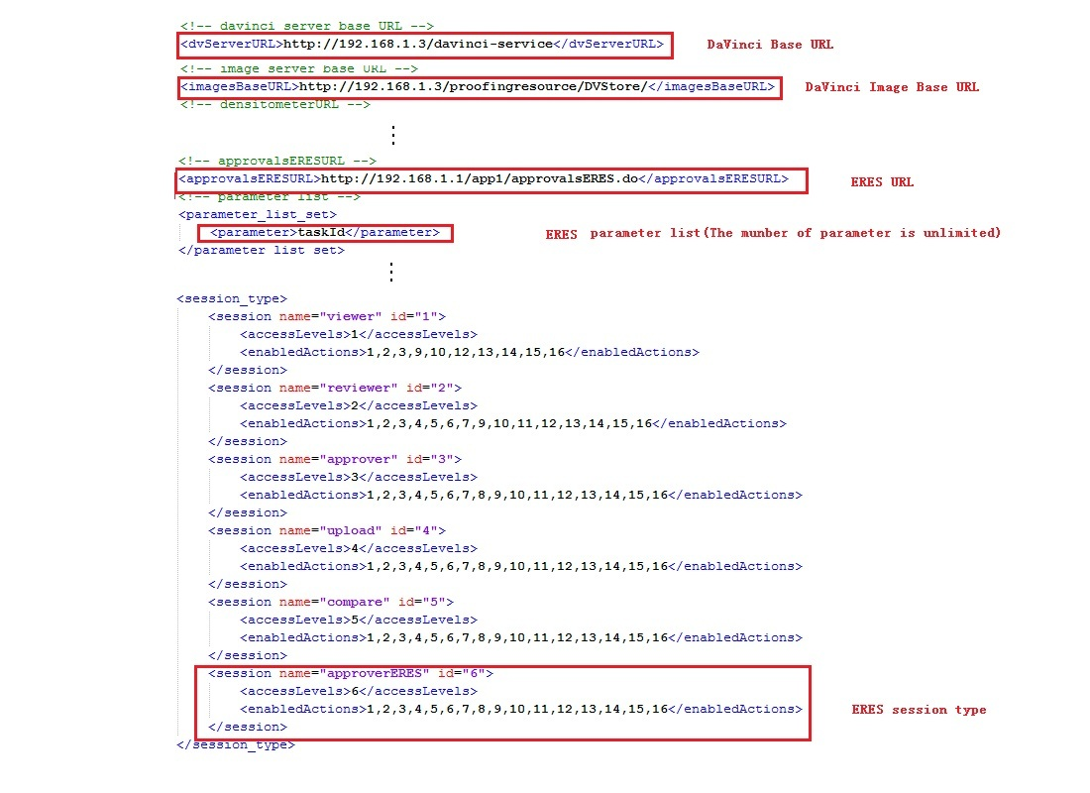

DaVinci Base URL should contain the DaVinci server’s URL;
DaVinci Image Base URL should contain the images URL for DaVinci server;
ESER URL should be configured to point the URL which be use for ESER;
ESER parameter is the one that configure what parameter(s) you want when calling ESER session.
Be sure to use value 6 as the value of parameter ‘sessionType’, and in this configuration file, you can sepicfy the ESER URL for this Web App1.
- DaVinci client Configuration file of app2
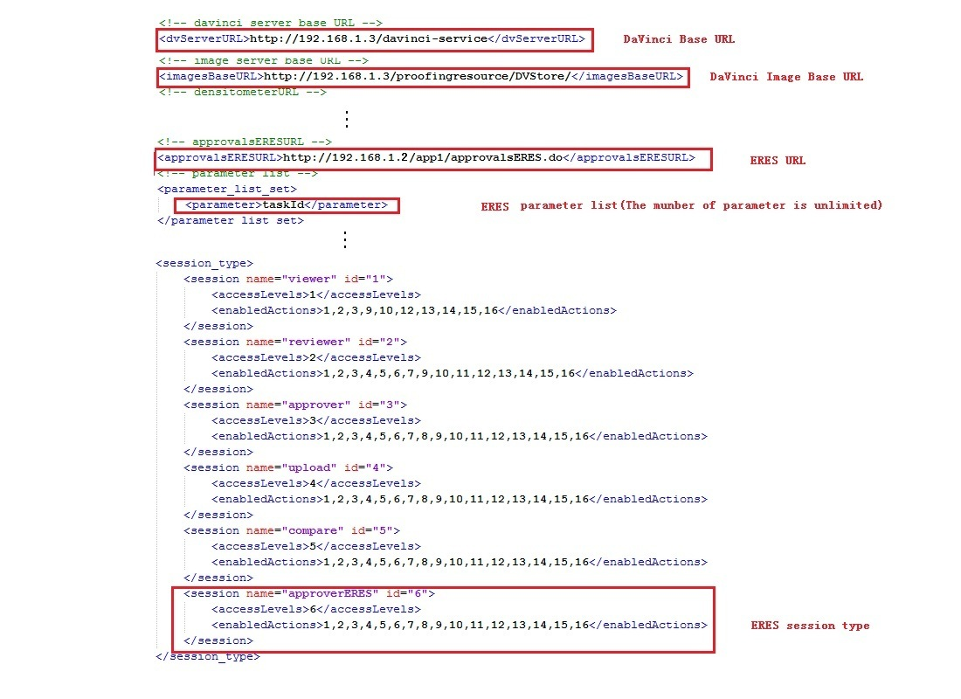

So for Web App2, you can configure different setting in the configuration.xml in Web App2.
(3) properties file of DaVinci server
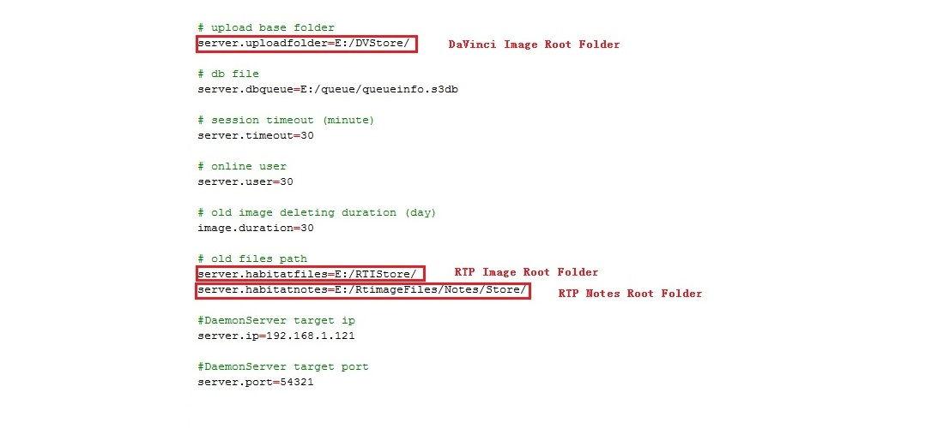
DaVinci Image Root Folder should be point to the folder that DaVinci server store the files uploaded by other Web applications, in the example above, they are Web App1 and Web App2. Also, it would store the processed files for DaVinci server. And we suggest to make sub folder for different web applications.
RTP Image Root Folder should be point to the path which store the images from RTP which use for convert on demand, RTP Notes Root Folder should be point to the path which store the notes from RTP which use for convert on demand.

